# LAB ASSIGNMENT-3

**1. To find Largest of Three Numbers**

**echo "Enter three numbers:"**

**read a b c**

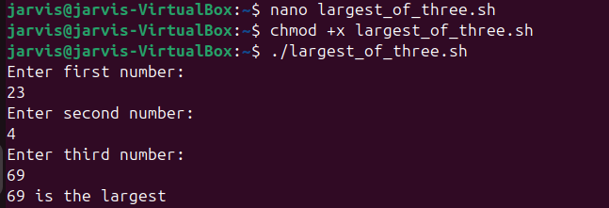**if (( a >= b && a >= c )); then**

**echo "$a is the largest"**

**elif (( b >= a && b >= c )); then**

**echo "$b is the largest"**

**else**

**echo "$c is the largest"**

**fi**

**2. To find a year is leap year or not.**

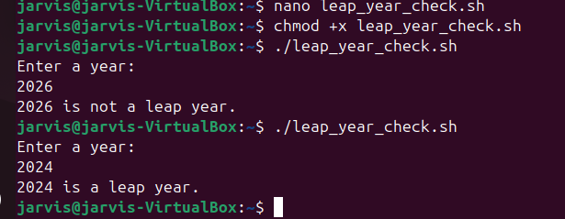**echo "Enter a year:"**

**read year**

**if (( year % 400 == 0 || (year % 100 != 0 && year % 4 == 0) )); then**

**echo "$year is a leap year"**

**else**

**echo "$year is not a leap year"**

**fi**

**3. To input angles of a triangle and find out whether it is valid triangle or not**

**echo "Enter 3 angles:"**

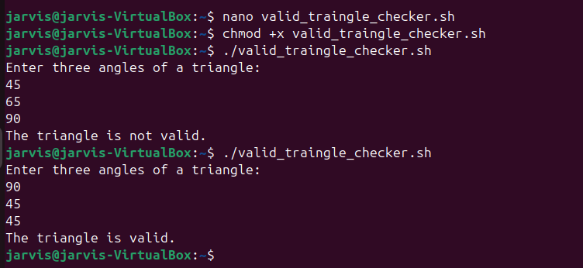**read a b c**

**sum=$((a + b + c))**

**if (( sum == 180 )); then**

**echo "Valid Triangle"**

**else**

**echo "Invalid Triangle"**

**fi**

**4. To check whether a character is alphabet, digit or special character.**

**echo "Enter a character:"**

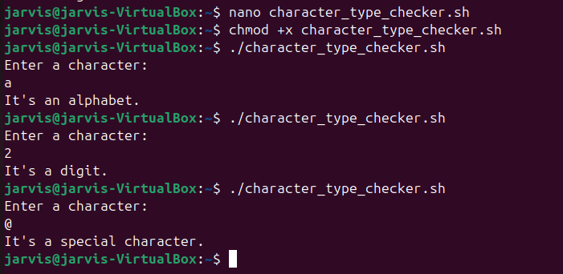**read ch**

**if [[ $ch =~ [a-zA-Z] ]]; then**

**echo "Alphabet"**

**elif [[ $ch =~ [0-9] ]]; then**

**echo "Digit"**

**else**

**echo "Special Character"**

**fi**

**5. To calculate profit or loss**

**echo "Enter cost price and selling price:"**

**read cp sp**

**if (( sp > cp )); then**

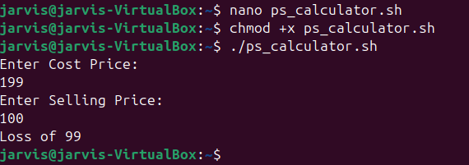 **echo "Profit of $((sp - cp))"**

**elif (( sp < cp )); then**

**echo "Loss of $((cp - sp))"**

**else**

**echo "No Profit No Loss"**

**fi**

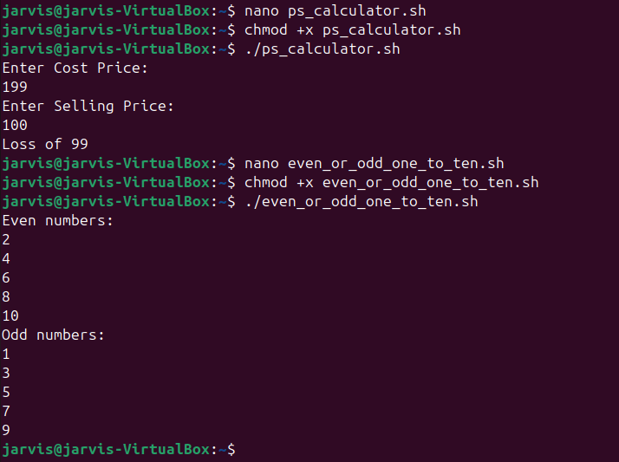**6. To print all even and odd number from 1 to 10**

**for i in {1..10}**

**do**

**if (( i % 2 == 0 )); then**

**echo "$i is Even"**

**else**

**echo "$i is Odd"**

**fi**

**done**

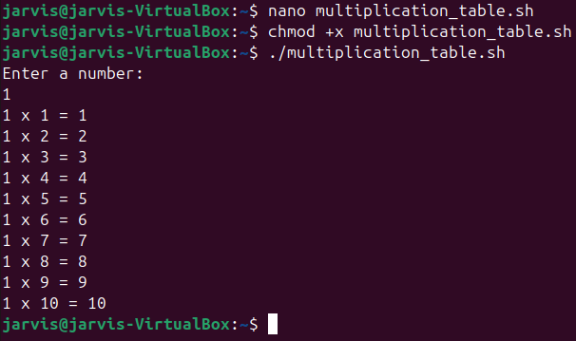**7. To print table of a given number**

**echo "Enter a number:"**

**read num**

**for i in {1..10}**

**do**

**echo "$num x $i = $((num * i))"**

**done**

**8. To find factorial of a given integer**

**echo "Enter a number:"**

**read n**

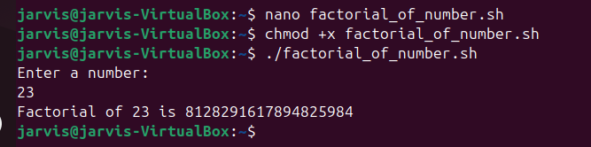**fact=1**

**for ((i=1; i<=n; i++))**

**do**

**fact=$((fact * i))**

**done**

**echo "Factorial of $n is $fact"**

**9. To print sum of all even numbers from 1 to 10.**

**sum=0**

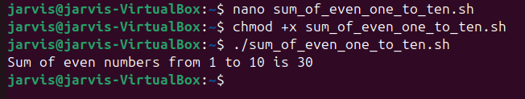**for i in {1..10}**

**do**

**if (( i % 2 == 0 )); then**

**sum=$((sum + i))**

**fi**

**done**

**echo "Sum of even numbers from 1 to 10 is $sum"**

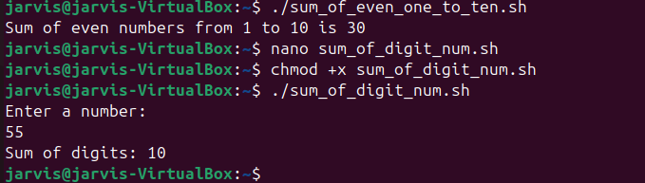**10. To print sum of digit of any number.**

**echo "Enter a number:"**

**read n**

**sum=0**

**while (( n > 0 ))**

**do**

**digit=$((n % 10))**

**sum=$((sum + digit))**

**n=$((n / 10))**

**done**

**echo "Sum of digits is $sum"**

**11. To make a basic calculator which performs addition, subtraction, Multiplication,**

**Division.**

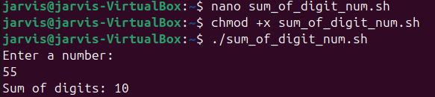**echo "Enter two numbers:"**

**read a b**

**echo "Choose operation (+ - * /):"**

**read op**

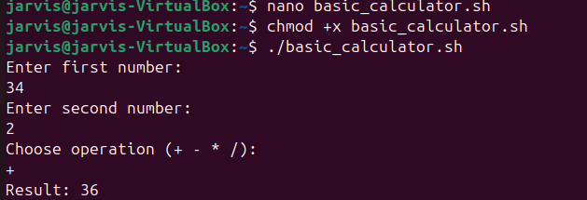

**case $op in**

**+) echo "Result = $((a + b))" ;;**

**-) echo "Result = $((a - b))" ;;**

**\*) echo "Result = $((a * b))" ;;**

**/)**

**if (( b != 0 )); then**

**echo "Result = $((a / b))"**

**else**

**echo "Division by zero error"**

**fi**

**;;**

**\*) echo "Invalid operation" ;;**

**Esac**

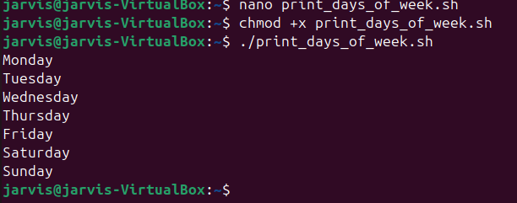**12. To print days of a week.**

**days=("Sunday" "Monday" "Tuesday" "Wednesday" "Thursday" "Friday" "Saturday")**

**for day in "${days[@]}"**

**do**

**echo "$day"**

**done**

**13. To print starting 4 months having 31 days.**

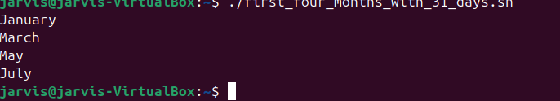**months=("January" "March" "May" "July")**

**for m in "${months[@]}"**

**do**

**echo "$m"**

**done**

**14. Using functions,**

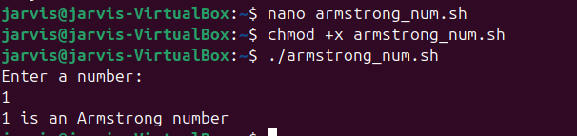**a. To find given number is Amstrong number or not**

**is_armstrong() {**

**num=$1**

**sum=0**

**temp=$num**

**while (( temp > 0 ))**

**do**

**digit=$((temp % 10))**

**sum=$((sum + digit * digit * digit))**

**temp=$((temp / 10))**

**done**

**if (( sum == num )); then**

**echo "$num is an Armstrong number"**

**else**

**echo "$num is not an Armstrong number"**

**fi**

**}**

**echo "Enter a number:"**

**read n**

**is_armstrong $n**

**b. To find whether a number is palindrome or not**

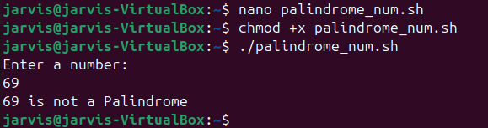**is_palindrome() {**

**num=$1**

**rev=0**

**temp=$num**

**while (( temp > 0 ))**

**do**

**digit=$((temp % 10))**

**rev=$((rev * 10 + digit))**

**temp=$((temp / 10))**

**done**

**if (( rev == num )); then**

**echo "$num is a Palindrome"**

**else**

**echo "$num is not a Palindrome"**

**fi**

**}**

**echo "Enter a number:"**

**read n**

**is_palindrome $n**

**c. To print Fibonacci series upto n terms**

**fibonacci() {**

**n=$1**

**a=0**

**b=1**

**echo -n "$a $b "**

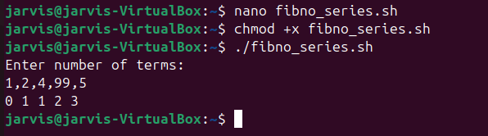

**for ((i=2; i<n; i++))**

**do**

**c=$((a + b))**

**echo -n "$c "**

**a=$b**

**b=$c**

**done**

**echo**

**}**

**echo "Enter number of terms:"**

**read n**

**fibonacci $n**

**d. To find given number is prime or composite**

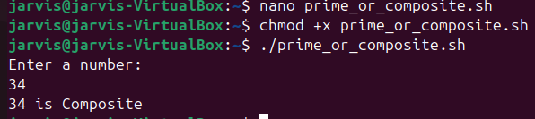**is_prime() {**

**n=$1**

**if (( n <= 1 )); then**

**echo "$n is neither prime nor composite"**

**return**

**fi**

**for ((i=2; i*i<=n; i++))**

**do**

**if (( n % i == 0 )); then**

**echo "$n is Composite"**

**return**

**fi**

**done**

**echo "$n is Prime"**

**}**

**echo "Enter a number:"**

**read n**

**is_prime $n**

**e. To convert a given decimal number to binary equivalent**

**dec_to_bin() {**

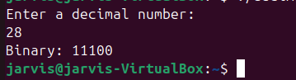 **num=$1**

**bin=""**

**while (( num > 0 ))**

**do**

**bin=$((num % 2))$bin**

**num=$((num / 2))**

**done**

**echo "Binary: $bin"**

**}**

**echo "Enter a decimal number:"**

**read n**

**dec_to_bin $n**